CSIT314 Software Development Methodologies - Group Project

Sprint 2 - US44: Suspend IDP category
Interior Design Platform - Platform Manager
All diagrams were drawn in draw.io. Open "US44 Suspend IDP category.drawio" in this folder to edit them - each diagram is its own page in that file. The exported images are in the "diagrams" folder.

Assumptions
- The system is the Interior Design Platform from the project specification. Sprint 2 covers the Interior Designer's log in / log out and company profile (US13 - US19) and the Platform Manager's log in / log out and IDP categories (US39 - US45).
- We follow B-C-E: the actor only talks to the boundary (page), the boundary only talks to the controller, and the controller works with the entity classes. There is one controller per use case.
- Following the lecturer's feedback (the same way as the other stories): the boundary checks all the input (required fields, lengths, formats, e.g. a category name is 3-50 characters) and trims spaces, then passes an entity object on. The controller just calls the entity and returns the result. The entity checks for duplicates and the database state (e.g. name already used, only Active categories are changed), then saves. Each B-C-E diagram has only one entity (a controller borrowed from another story doesn't count).
- Being logged in as a Platform Manager (UC39) is the precondition of these use cases, so the pages and the B-C-E / sequence diagrams don't check the manager again (no PlatformManagerLoginController). managerLoginRequired in app.py only sends someone with no session to /manager/login.
- The manager starts from the category details page (US42). The "Suspend" button is only shown while the category is Active.
- Suspending asks "Are you sure?" first. The box is plain HTML on the details page (no JavaScript), like US6 and US11. The category shown in the box is loaded by borrowing US42's ViewIDPCategoryController.viewIDPCategory(categoryId) - US44's own controller only suspends.
- "Users can no longer see or select it": a Suspended category is not in the designer's IDP category drop-down (US20), and a form posted with its id is rejected.
- Suspending keeps the category row and the IDPs already in it - nothing is deleted. The manager can still find it with the search (US45) and view it (US42).
- A category that is already Suspended, or doesn't exist, can't be suspended: the entity only changes an Active row, so the page shows "This IDP category cannot be suspended". There is no separate isActive() check before it.

1. User story
Story ID | US44
User story | As a platform manager, I want to suspend an IDP category so that users can no longer see or select it.
Actor | Platform Manager
Priority | Medium
Story points (estimate) | 2
Acceptance criteria | 1. Given an Active category's details page, there is a "Suspend" button.  2. Given I click "Suspend", then I see an "Are you sure?" box with OK and Cancel.  3. Given I click OK, then the category becomes Suspended and I see "IDP category suspended successfully".  4. Given I click Cancel, then the box closes and nothing changes.  5. A Suspended category is no longer offered to designers when they add an IDP, and can't be selected.  6. Given the category is already Suspended, then it can't be suspended again ("This IDP category cannot be suspended").
Tasks | T44.1 Write the use case description and draw the use case diagram  T44.2 Draw the B-C-E class diagram and the sequence diagram  T44.3 Draw the wireframes for the Suspend button, the confirmation, the suspended category and the designer's drop-down  T44.4 Write the unit tests first (TDD) for IDPCategory.suspendIDPCategory(), SuspendIDPCategoryController and the page  T44.5 Code IDPCategory.suspendIDPCategory() (only an Active row is changed)  T44.6 Code SuspendIDPCategoryController and SuspendIDPCategoryPage with the confirmation box (the box borrows US42's ViewIDPCategoryController to load the category)  T44.7 Make sure the US20 category drop-down (getAvailableCategories()) skips Suspended categories  T44.8 Run the test cases, fix bugs and push to the repo so the CI pipeline runs the unit tests

2. Use case diagram
The user story becomes one use case, UC44 Suspend IDP category. The Platform Manager is the only actor.
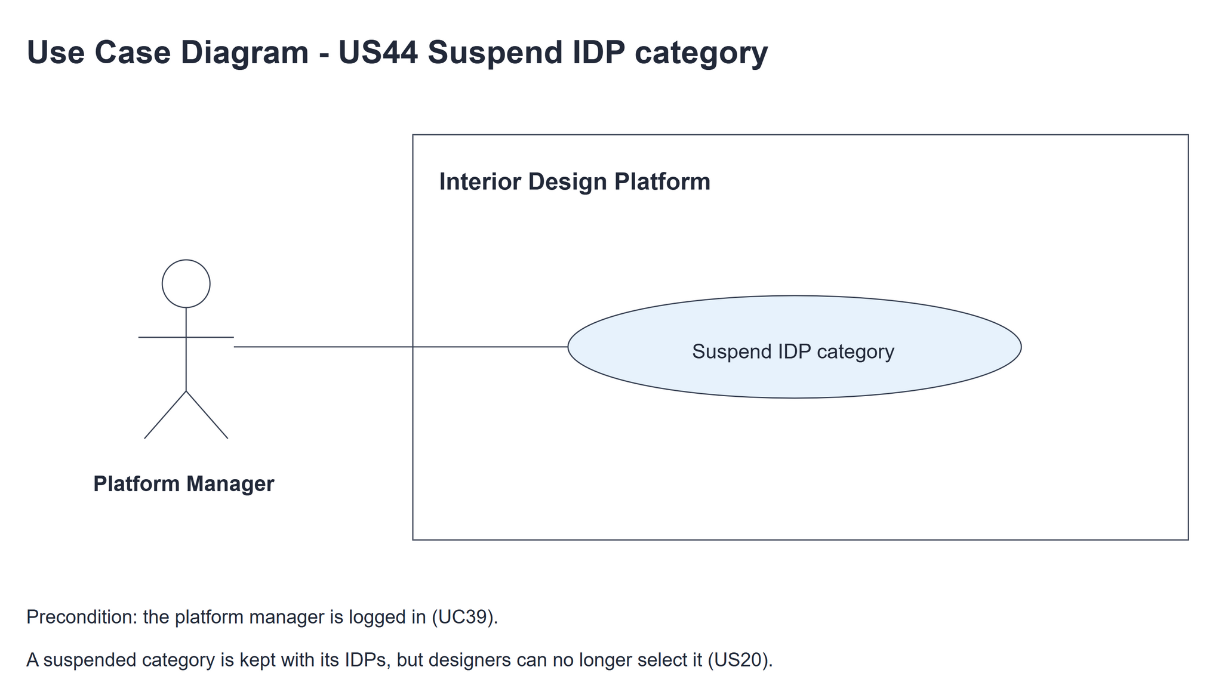
Figure 1: Use case diagram for US44 Suspend IDP category

3. Use case description
Use case | UC44 Suspend IDP category
Actor | Platform Manager
Brief description | The Platform Manager suspends an IDP category so users can no longer see or select it.
User story | US44: As a platform manager, I want to suspend an IDP category so that users can no longer see or select it.
Preconditions | The Platform Manager is logged in (UC39) and is viewing the category (UC42).
Trigger | The Platform Manager clicks "Suspend" on the category details page.
Basic flow | 1. The Platform Manager clicks "Suspend".  2. The system loads the category (through US42's controller).  3. The system shows the "Are you sure?" box.  4. The Platform Manager clicks "OK".  5. The system sets the category to Suspended (only if it is still Active).  6. The system shows the details page with the Suspended badge and "IDP category suspended successfully".
Alternative flows | 2a. The category doesn't exist: the system shows "This IDP category cannot be suspended". The use case ends.  4a. The Platform Manager clicks "Cancel": the box closes and nothing changes.  5a. The category is no longer Active (already Suspended) or no longer exists: the system shows "This IDP category cannot be suspended".
Postconditions | The category is Suspended. It stays in the database with its IDPs.  Designers can no longer select it for an IDP (US20).

4. Wireframes
The wireframes were drawn in draw.io. They are low-fidelity: they show the layout and the flow, not the final colours. The orange numbers match the notes under each screen.

4a - Suspend button
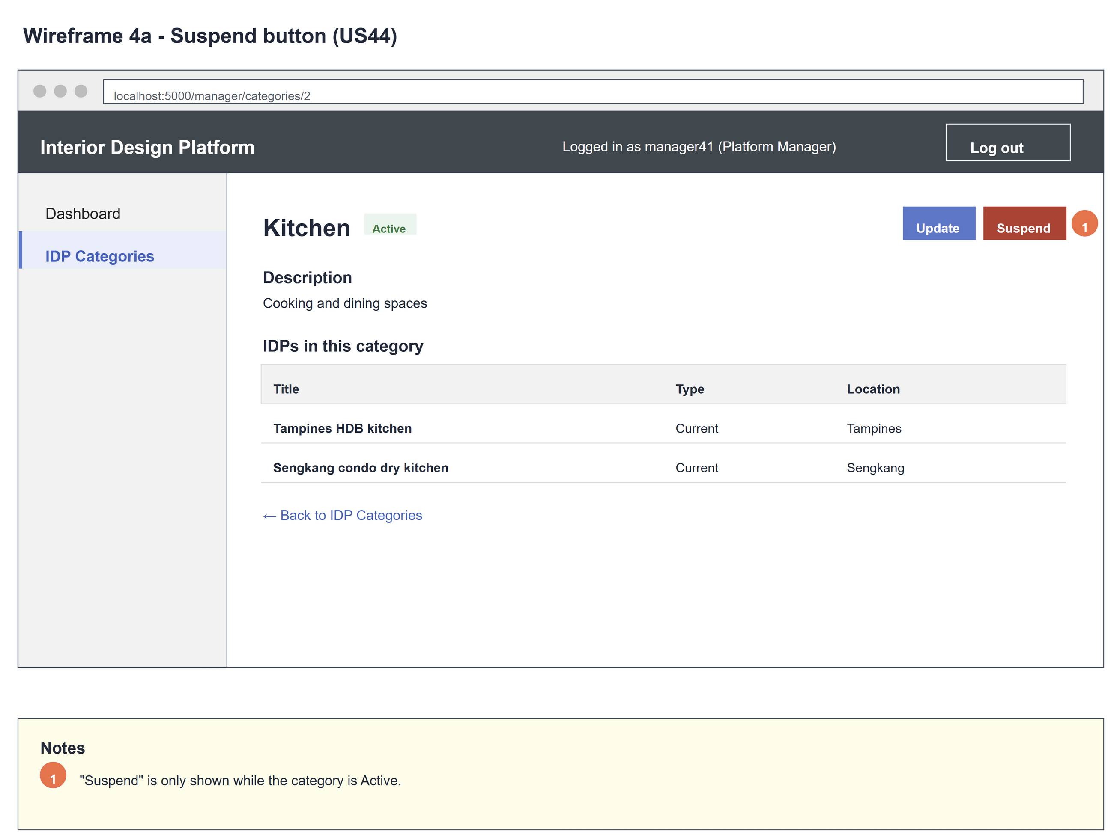
Figure 2: Wireframe 4a - Suspend button (US44)

4b - Confirm suspend
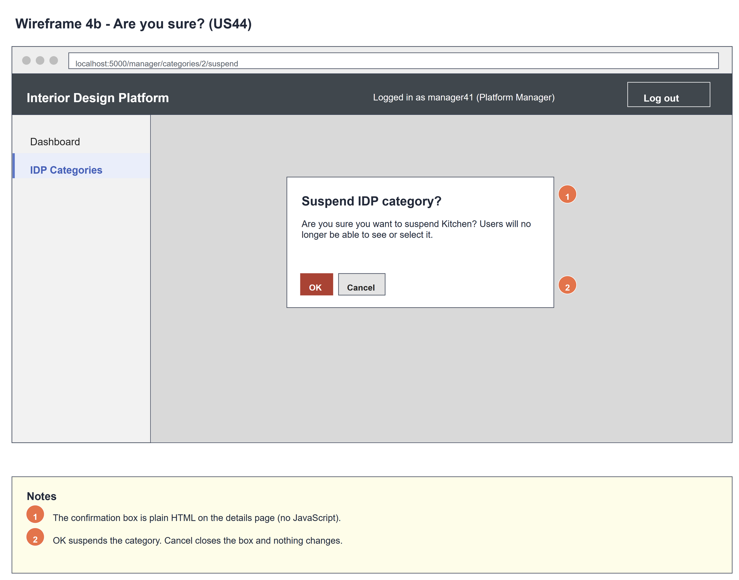
Figure 3: Wireframe 4b - Confirm suspend (US44)

4c - Category suspended
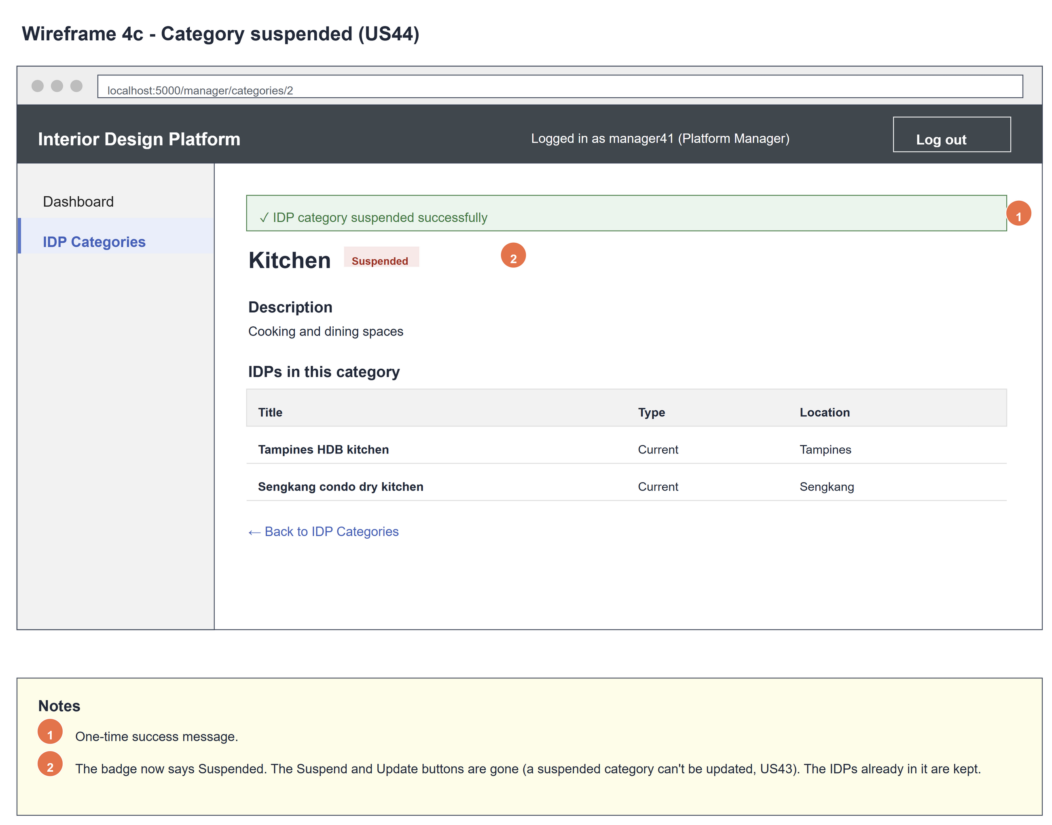
Figure 4: Wireframe 4c - Category suspended (US44)

4d - Not selectable
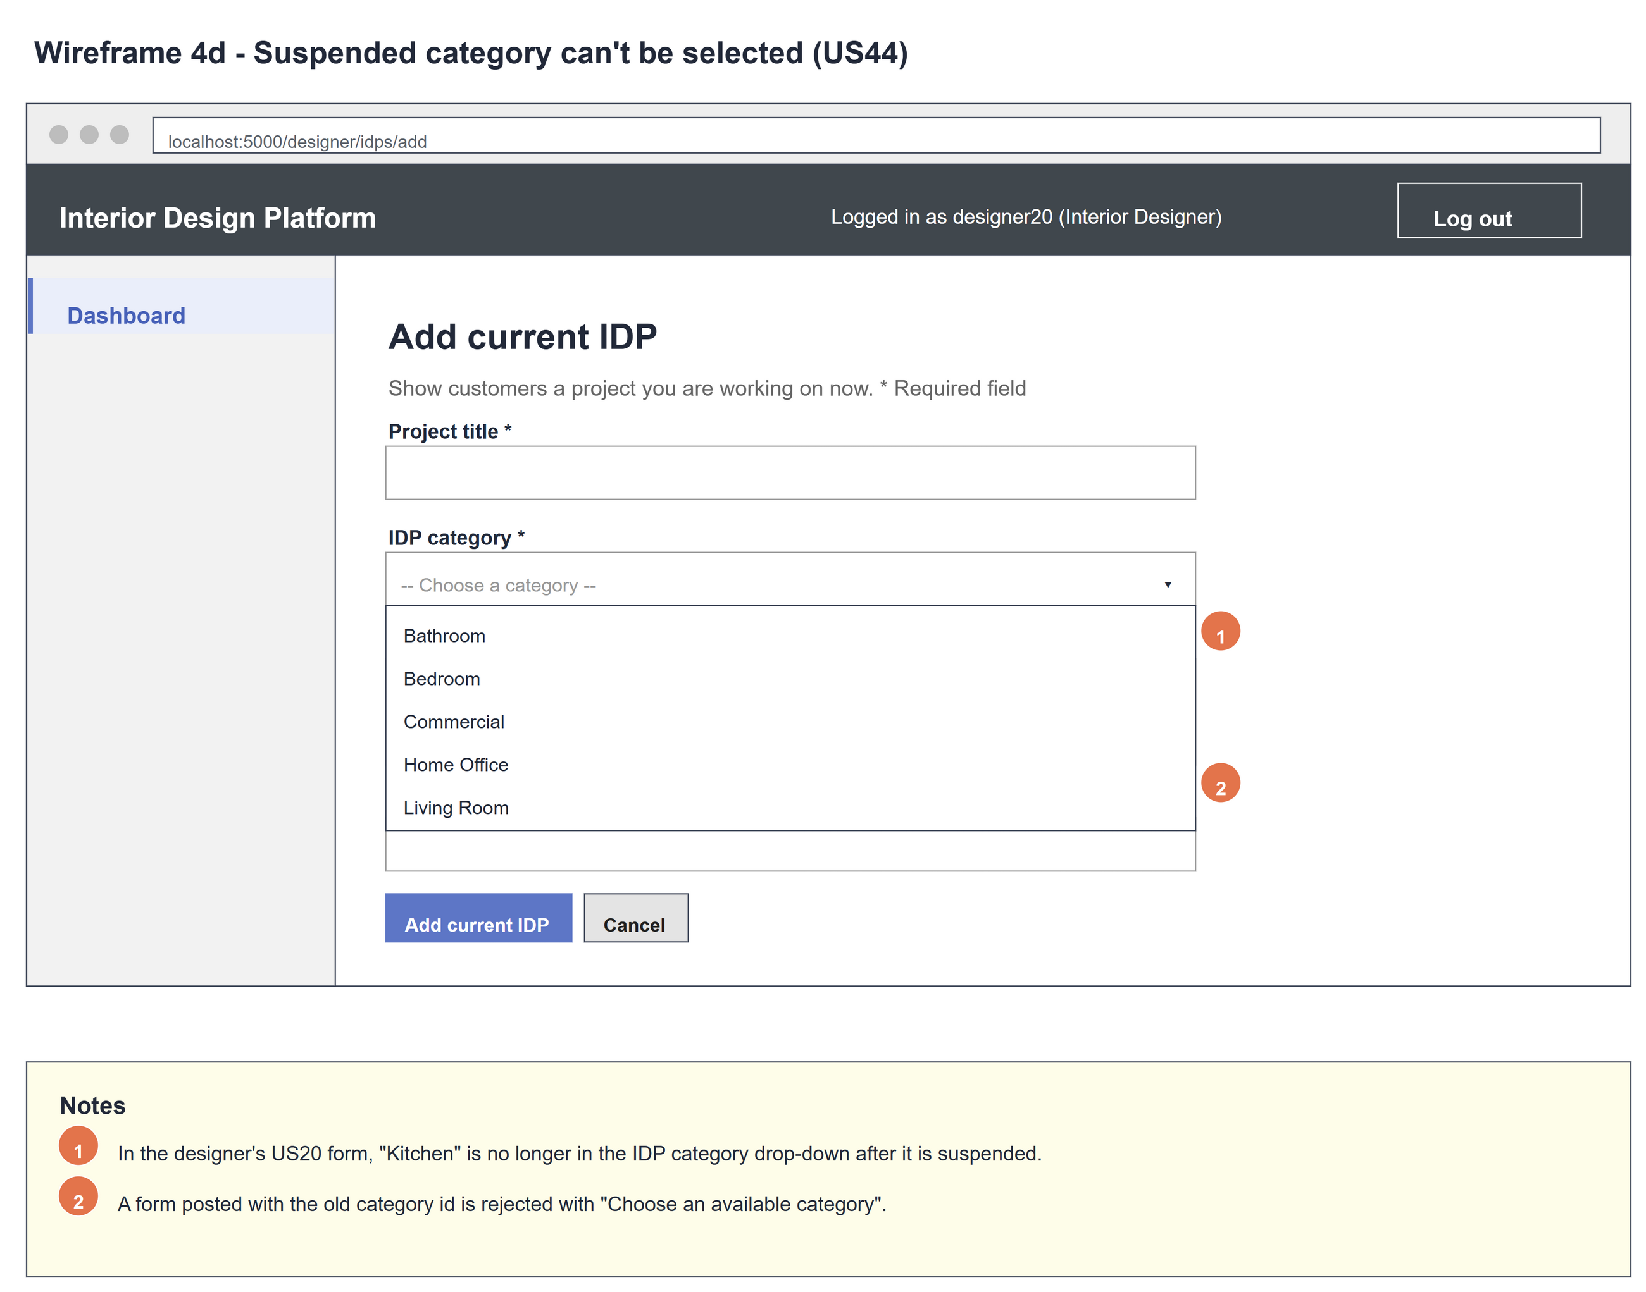
Figure 5: Wireframe 4d - Not selectable (US44)

5. B-C-E class diagram
The solid line means the boundary calls the controller. The dashed lines mean the controller uses the other classes. Only the operations needed for this use case are shown, with the same names as the code.
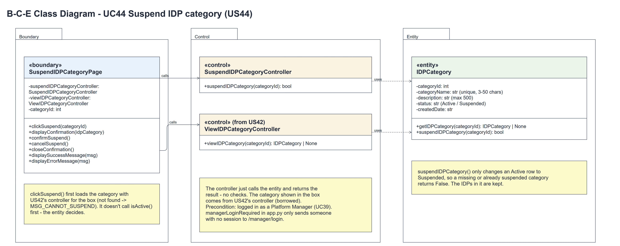
Figure 6: B-C-E class diagram for US44 Suspend IDP category
Layer | Class | What it does
Boundary | SuspendIDPCategoryPage | The Suspend button and the "Are you sure?" box. clickSuspend(categoryId) first loads the category through US42's controller and shows the box (displayConfirmation(idpCategory)), or MSG_CANNOT_SUSPEND if there is no such category; confirmSuspend() asks the controller to suspend, cancelSuspend() closes the box.
Control | SuspendIDPCategoryController | Controller for UC44. suspendIDPCategory() just calls the entity and returns the result.
Control | ViewIDPCategoryController (from US42) | Borrowed by the page (one controller per use case): viewIDPCategory(categoryId) loads the category shown in the box.
Entity | IDPCategory | suspendIDPCategory(categoryId) changes only an Active row to Suspended, so a missing or already suspended category returns False - the page doesn't call isActive() first. getIDPCategory(categoryId) is used by US42's controller.

6. Sequence diagram
The sequence diagram follows UC44. The page first loads the category with US42's controller; the first alt shows the box, or "This IDP category cannot be suspended" when there is no such category (alternative flow 2a). The second alt is OK or Cancel. On OK the controller just calls the entity, which only suspends an Active category; the inner alt shows the success or error message.
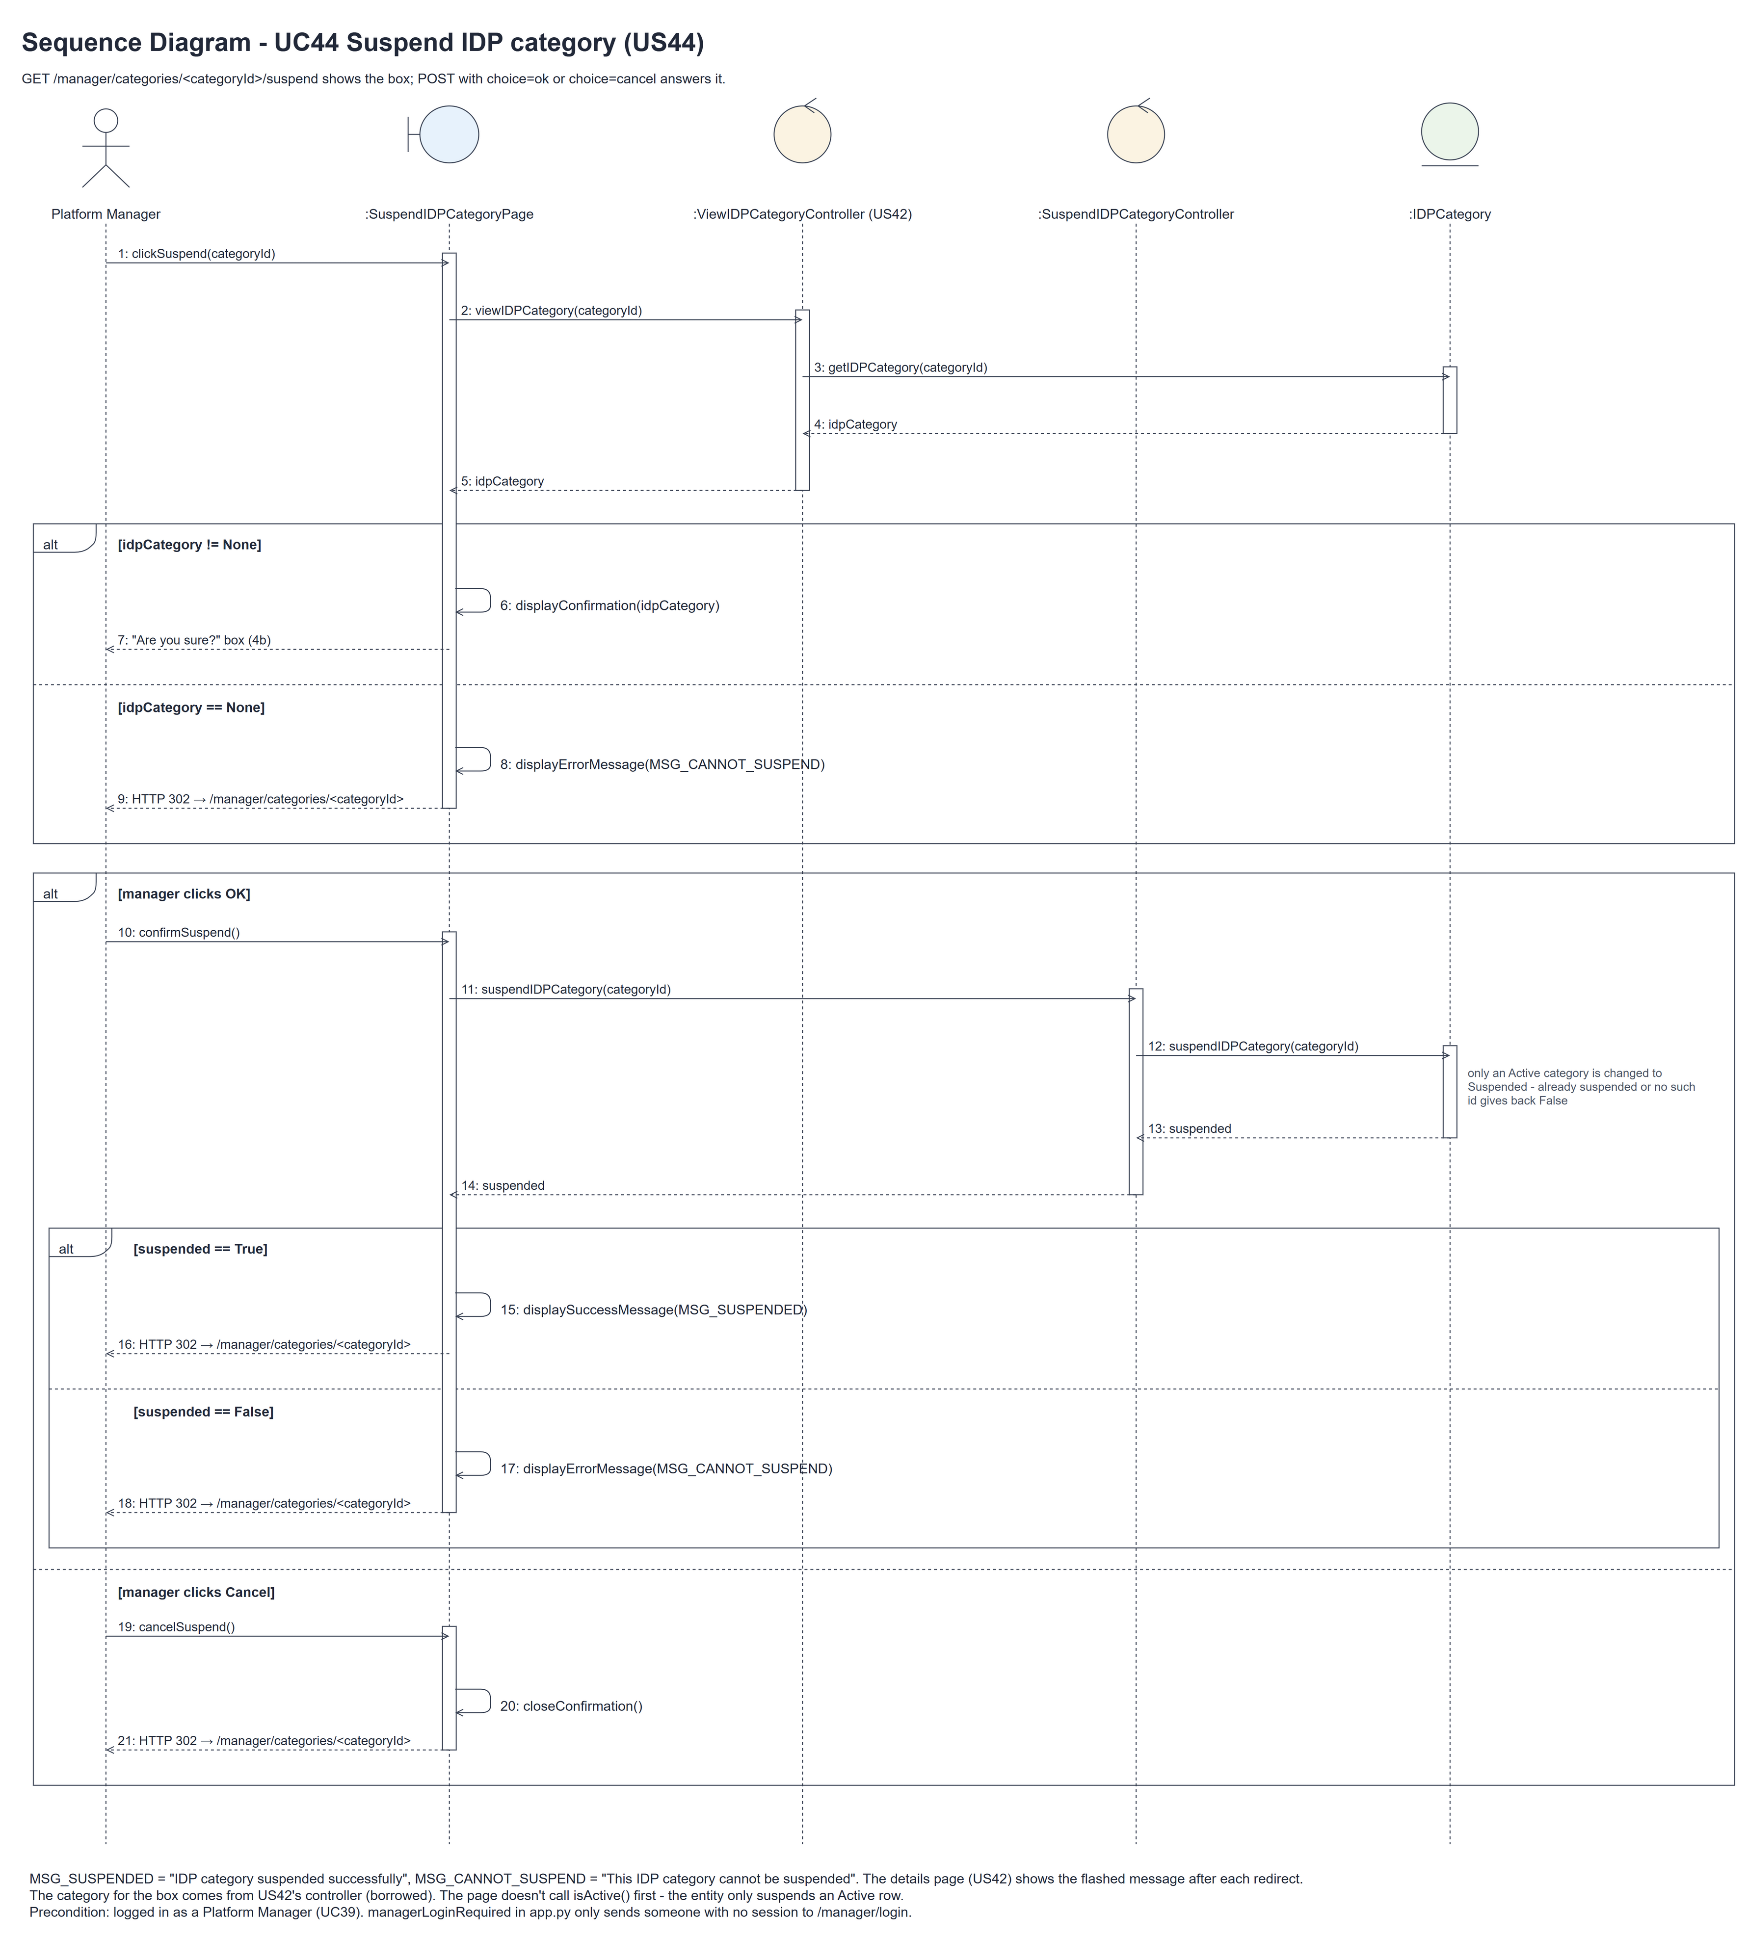
Figure 7: Sequence diagram for UC44 Suspend IDP category

7. Test cases
Test data used below (same as database/seedData.py and the test files): user profiles User Admin (id 1), Interior Designer (id 2), Customer (id 3) and Platform Manager (id 4), all Active. User accounts admin01 / Admin@123 (User Admin) and cust001 / Cust@123 (Customer). The manager account manager44 / Manager@123 (Daniel Tan, Platform Manager profile) is made first with UC8. IDP categories are made in each test with UC41, e.g. Kitchen ("Cooking and dining spaces"), Bedroom and Office. The designer account designer44 / Design@123 (Interior Designer profile) is used to check the US20 drop-down.

7a. System test cases (black box)
Equivalence partitioning and boundary value analysis were used to pick the test data. Fill in "Actual result" and "Pass/Fail" after running each test.
Test ID | Scenario | Prerequisites | Test steps | Test data | Expected result | Actual result | Pass / Fail
TC44.1 | Suspend a category | Kitchen is Active. | 1. View Kitchen  2. Click "Suspend"  3. Click "OK" | Kitchen | "IDP category suspended successfully". The badge says Suspended and the Suspend and Update buttons are gone. | "IDP category suspended successfully" was shown. The badge said Suspended and the Suspend and Update buttons were gone. | Pass
TC44.2 | Cancel | Kitchen is Active. | 1. Click "Suspend"  2. Click "Cancel" | - | The box closes. Kitchen is still Active.
TC44.3 | Designers can't select it | TC44.1 done. Bedroom is Active. | 1. Log in as designer44  2. Open Add current IDP | - | The drop-down has Bedroom but not Kitchen.
TC44.4 | Old form can't use it | Designer's form opened before TC44.1. | 1. Submit the old form with Kitchen | Kitchen's id | "Choose an available category". Nothing saved.
TC44.5 | IDPs are kept | Kitchen has an IDP. | 1. Suspend Kitchen  2. View Kitchen | - | The IDP is still listed.
TC44.6 | Already suspended | Kitchen is Suspended. | 1. Post OK to /manager/categories/<id>/suspend | - | "This IDP category cannot be suspended".
TC44.7 | Not logged in | Not logged in. | 1. Post OK to the suspend URL | - | The manager login page is shown. Kitchen is still Active.
TC44.8 | Category not found | Logged in as manager44. | 1. Open /manager/categories/9999/suspend | categoryId 9999 | "This IDP category cannot be suspended". No box is shown.

7b. Unit test cases (for TDD)
These are written before the code (test-driven development) and run with pytest. They cover normal inputs, abnormal inputs and boundary values. Each one matches a test function in tests/test_us44_suspendIDPCategory.py (UT44.n = test_ut44_n_...).
Test ID | Class and method | Input / setup | Expected output | Type | Pass / Fail
UT44.1 | SuspendIDPCategoryController.suspendIDPCategory() | Active Kitchen | True. Status Suspended | Normal | Pass
UT44.2 | SuspendIDPCategoryController.suspendIDPCategory() | Already Suspended | Returns false | Abnormal | Pass
UT44.3 | SuspendIDPCategoryController.suspendIDPCategory() | Id 9999 | Returns false | Abnormal | Pass
UT44.4 | SuspendIDPCategoryController.suspendIDPCategory() | Kitchen with one IDP | The IDP is kept | Normal | Pass
UT44.5 | IDPCategory.isActive() (used by the US20 drop-down) | Active, Suspended | True, false | Normal | Pass
UT44.6 | IDPCategory.suspendIDPCategory() | Called twice | True, then false | Boundary | Pass
UT44.7 | AddCurrentIDPPage.getAvailableCategories() (US20) | Kitchen Suspended, Bedroom Active | Only Bedroom | Normal | Pass
UT44.8 | AddCurrentIDPController.addCurrentIDP() (US20) | Suspended Kitchen chosen | False. No IDP saved | Abnormal | Pass
UT44.9 | AddCurrentIDPPage (US20 form) | designer44 opens the form | Bedroom shown, Kitchen not shown | Normal | Pass
UT44.10 | SuspendIDPCategoryPage.clickSuspend() | GET the suspend URL | "Suspend IDP category?" box. Still Active | Normal | Pass
UT44.11 | SuspendIDPCategoryPage.confirmSuspend() | POST choice=ok | "IDP category suspended successfully". Suspended | Normal | Pass
UT44.12 | SuspendIDPCategoryPage.cancelSuspend() | POST choice=cancel | Redirect to details. Still Active | Normal | Pass
UT44.13 | SuspendIDPCategoryPage.confirmSuspend() | Already Suspended, POST choice=ok | "This IDP category cannot be suspended" | Abnormal | Pass
UT44.14 | View page after suspending | GET the details page | No Suspend button | Boundary | Pass
UT44.15 | /manager/categories/<id>/suspend (managerLoginRequired) | Not logged in, POST choice=ok | Redirects to /manager/login. Still Active | Abnormal | Pass
UT44.16 | SuspendIDPCategoryPage.clickSuspend() | GET /manager/categories/9999/suspend | "This IDP category cannot be suspended". No box | Abnormal | Pass
UT44.17 | SuspendIDPCategoryPage.clickSuspend() | Already Suspended, GET the suspend URL | The box is shown (the page doesn't call isActive() first); OK then gives "This IDP category cannot be suspended" | Boundary | Pass

